1.List 3 real-world devices in your home or college that use SMPS (Switched Mode Power Supply) and 2 devices that use UPS (Uninterruptible Power Supply), explaining in one line why each device needs that type of power supply.
-> 1. Devices that use SMPS (Switched Mode Power Supply):
- Desktop Computer – It uses an SMPS to convert AC power from the wall socket into different DC voltages required by the computer components.
- LED Monitor – It needs an SMPS to provide stable and efficient power for the display circuits.
- Laptop Charger – It uses SMPS technology to convert high-voltage AC power into the correct DC output needed to charge the laptop battery.
Devices that use UPS (Uninterruptible Power Supply):
- Desktop Computer in the College Lab – It uses a UPS to keep the system running for a short time during power cuts and prevent data loss.
- Wi-Fi Router at Home – It can be connected to a UPS so that the internet continues to work even when there is a temporary power failure.
2.Draw and label a diagram showing the main internal components of a typical SMPS unit found in a desktop PC, including AC input, rectifier, transformer, and DC output sections.<br><br><em><strong>Hint:</strong> You can hand-draw and upload a photo, or use any free diagram tool like draw.io.</em>

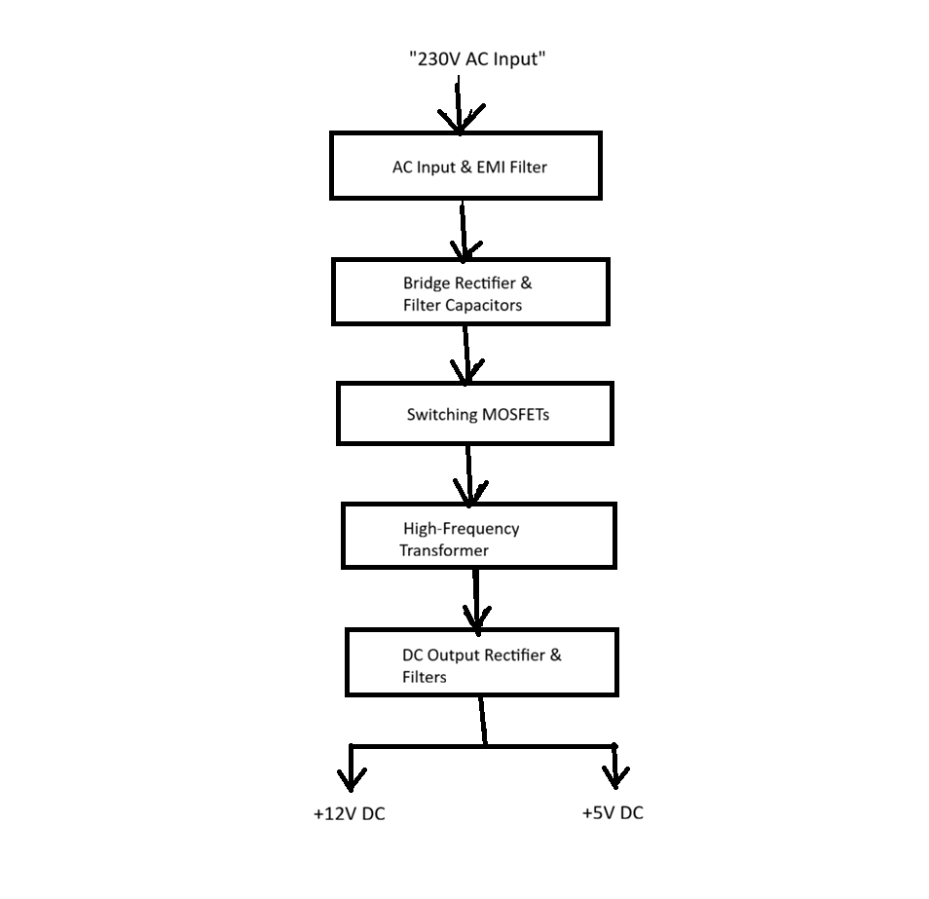
Internal Components of SMPS and Their Functions
- AC Input & EMI Filter:
This is where the 230V AC power from the wall socket enters the PC. The EMI filter removes any electrical noise and protects the SMPS from high voltage spikes.
- Bridge Rectifier & Filter Capacitors:
The bridge rectifier converts the incoming Alternating Current (AC) into Direct Current (DC). The large filter capacitors then smooth out this bumpy DC into high-voltage raw DC.
- Switching MOSFETs:
These act like ultra-fast electronic switches. They turn the DC power ON and OFF thousands of times per second to create high-frequency AC pulses.
- High-Frequency Transformer:
This transformer takes the high-frequency AC and steps down the high voltage into safe, low voltages needed for a computer. It also separates the dangerous high-voltage side from the safe low-voltage side.
- DC Output Rectifier & Filters:
This final stage converts the low-voltage AC back into clean, smooth, and steady DC power. It delivers the final stable outputs like +12V DC and +5V DC to run components like the CPU, Motherboard, and Hard Drives.

3.Take photos or find clear images online of the following power connectors: ATX 24-pin motherboard connector, SATA power connector, Molex connector, and PCIe 6/8-pin connector. For each, write its name, the devices it powers, and one safety tip for connecting/disconnecting it.

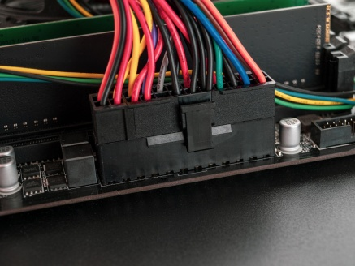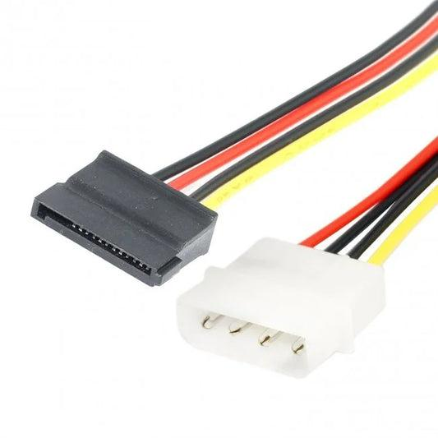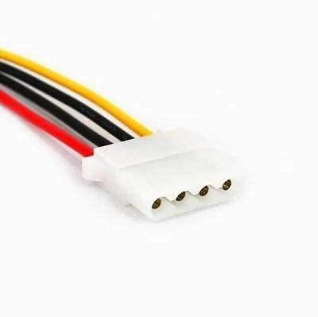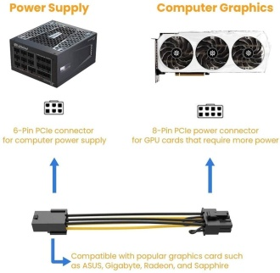

3. Power Connectors and Their Uses
1. ATX 24-pin Motherboard Connector
- Devices it powers: It provides power to the motherboard and its main components.
- Safety Tip: Always switch off the power supply and unplug the power cable before connecting or disconnecting this connector.
2. SATA Power Connector
- Devices it powers: It is used to supply power to SATA HDDs, SSDs, and some DVD drives.
- Safety Tip: Insert and remove the connector gently without forcing it, as the plastic connector can break.
3. Molex Connector
- Devices it powers: It is commonly used for older hard drives, case fans, and optical drives.
- Safety Tip: Hold the connector firmly while removing it and avoid pulling directly on the wires.
4. PCIe 6/8-pin Connector
- Devices it powers: It provides extra power to graphics cards (GPUs).
- Safety Tip: Make sure the connector is fully locked into place before turning on the computer to avoid power issues.
4.Imagine you are setting up a new gaming PC. List the steps you would follow to connect the SMPS to the motherboard, graphics card, and storage devices, mentioning which specific cables and connectors are used for each.
-> Steps to Connect the SMPS in a New Gaming PC
- First, I would make sure the SMPS is switched off and the power cable is unplugged for safety.
- I would connect the 24-pin ATX connector from the SMPS to the motherboard because it provides the main power to the motherboard.
- Then, I would connect the 8-pin CPU power connector to the motherboard near the CPU socket to supply power to the processor.
- After that, I would connect the PCIe 6/8-pin connector from the SMPS to the graphics card (GPU) so that it gets enough power for gaming.
- Next, I would connect the SATA power connectors to the SSD or HDD to provide power to the storage devices.
- Finally, I would check that all the cables are connected properly, plug in the main power cable, and turn on the PC to make sure everything is working correctly.

